**AssetVodafone Task Manual Documentation**

This project was generated with [Angular CLI](https://github.com/angular/angular-cli) version 8.3.23.

## Development server

Run ng serve for a dev server. Navigate to http://localhost:4200/. The app will automatically reload if you change any of the source files.

***Our Components***

**1 – Videos Component**

Which display the Channel list of videos using YouTube v3 API,

And pass the video Id to Another Component “details Component”

Through the below function which capture the id and go to the details

Component through *router.navigate*

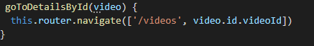

**2- Details Component**

This component is responsible for displaying the video through it’s “id” that subscribed in the YouTube service

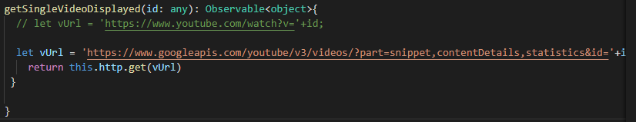

**3- page Not Found Component**

If the user hit a random id or character, or try to access any wrong url by any way

This action will lead him to this component “Not Found !”

***Services***

**1-YoutubeService**

We have only one service that is used in interaction between the 2 component with each other, and every component with the API

# *Routing and navigation*

The Angular [Router](https://angular.io/api/router/Router) enables navigation from one [view](https://angular.io/guide/glossary#view) to the next as users perform application tasks.

This guide covers the router's primary features, illustrating them through the evolution of a small application that you

### Router imports :

### import { [RouterModule](https://angular.io/api/router/RouterModule), [Routes](https://angular.io/api/router/Routes) } from '@angular/router';

A router has no routes until you configure it. The following snapshot from

*app-routing.module.ts* file in our project, creates four route definitions, configures the router via the [RouterModule.forRoot()](https://angular.io/api/router/RouterModule" \l "forRoot) method, and adds the result to the AppModule's imports array.

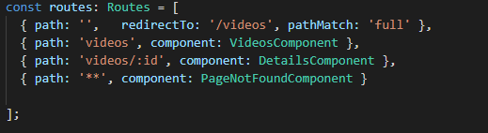

***Problems I met***

unsafe Url When I try to bind the Url in the Iframe tag

**The solution:**

is to use *DomSanitizer* which helps preventing Cross Site Scripting Security bugs (XSS) by sanitizing values to be safe to use in the different DOM contexts.

**Reference :**

<https://stackoverflow.com/questions/38037760/how-to-set-iframe-src-without-causing-unsafe-value-exception/38037914#38037914>

***Note:***

While browsing the folders in the project you will see a folder named Documentation, that is Automated Documentation generated through [***Compodoc***](https://compodoc.github.io/compodoc/)